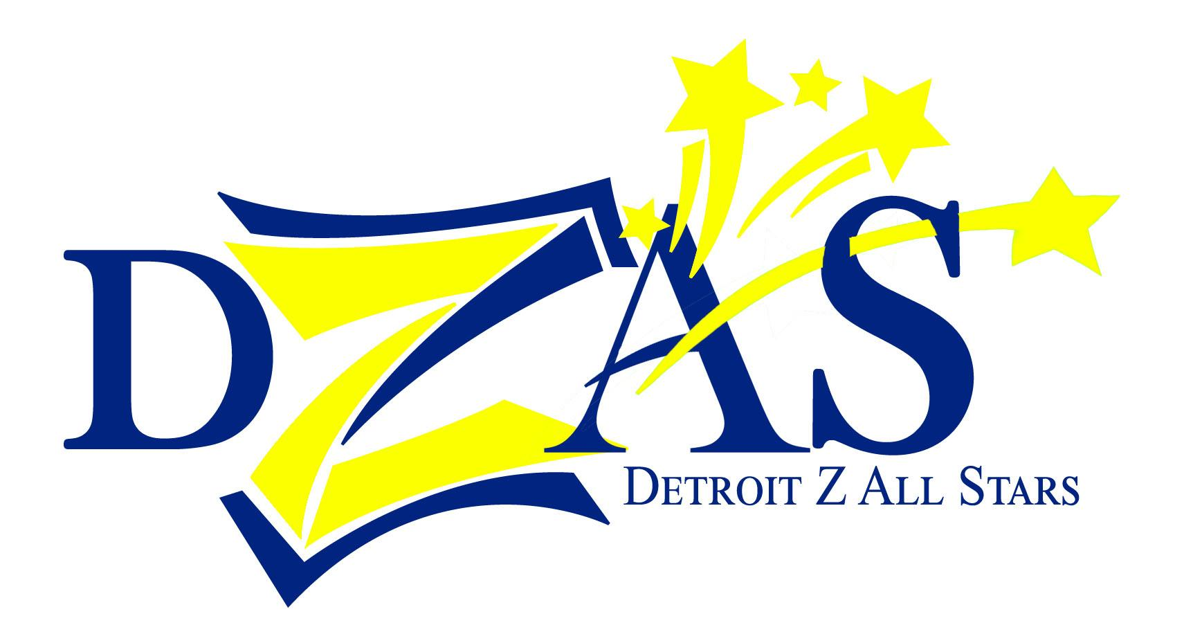
FOR IMMEDIATE RELEASE

Contact:
Letitia Wesley
(313) 363-6496
Lwesley@comcast.net

Detroit’s Largest Zumba® Fitness Party
Friday, October 17, 2014, 7-8:30pm
Ditch the workout and join the party!™

WHAT:
Join us for the third edition of Detroit's Largest Zumba® Fitness Party! Featuring 14 local instructors and 50 local vendors and community partners, most of which are small businesses in the Detroit metro area.

WHEN:
Friday, October 17, 2014
5:30–7 p.m. Shop with 50 local vendors
7–8:30 p.m. Zumba® Fitness Party
8:30–9 p.m. More shopping!

WHERE:
Bert’s Entertainment Warehouse, 2727 Russell St, Detroit, MI 48207

WHO:
Detroit Zumba® All Stars (DZAS) is a team of Zumba® Fitness instructors who lead classes in the city of Detroit: Chandra Floyd, Marius Padieu, Patti Dukes Jordan and Letitia Wesley.

WHY:
Organizer Chandra Floyd: “If you've always wanted to try Zumba®, or you're already a die-hard fan, this is the event for you! There are 14 instructors to choose from and a wide variety in musical styles. It's a fun, easy to follow cardio dance fitness party, and no experience is necessary!”

“The goal is to encourage health and wellness in the city of Detroit,” says Floyd. “This event also supports the good things that are going on in the city, including local small businesses.”

TICKETS:
$10; available at www.DZASBerts2014.eventbrite.com. Tickets include entry into a door prize drawing.

OTHER:
Bring a canned good or cash donation for Gleaners Community Food Bank, and receive an extra entry in the door prize drawings.

ED. NOTE:
DZAS will provide two VIP tickets to give away.

###

DZAS is organized by four licensed Zumba® Fitness instructors who lead classes in the city of Detroit : Chandra Floyd , Marius Padieu, Patti Dukes Jordan, and Letitia Wesley. We are committed to helping our participants build confidence, strength and good health. We have deep roots in Detroit, and want to be part of the positive rebirth of the city.

